Bullet-Hell Idea
Research
The Shoot ‘em up genre is a sub-genre of the Shooter genre of video games. The bullet-hell genre goes as far back as 1961, invented by a group of students to create something never seen before.
“It all began in a musty computer lab on the M.I.T. campus in 1961, where students commandeered the first user-oriented computer, the PDP-1, to design something the world had never seen: a computer game. Their creation, Spacewar!, is now regarded as the original shoot ‘em up. Against a primitive vector starfield, students controlled 2 skeletal spaceships, firing upon one another while getting sucked into the gravitational field of a blazing sun.”
This genre would quickly pick up steam in the Japanese gaming market with the iconic game of its time, Space Invaders by Tomohiro Nishikado. Later this genre would evolve into unique and creative games using different styles and strategic gameplay such as vertical, side-scrolling shmups etc.
I took the time playing and carefully analysing different bullet-hell titles to see what differentiates them from the rest.
Touhou Project: Imperishable Night has 3 playable characters, each come with a panther with their own quirks, different attributes, and playstyles. Swapping between team mates lessens the amount of enemy and boss bullets on-screen making for a more stress free experience.
While Undertale is an indie game, it has bullet-hell like elements and a rather unique shmup that each enemy has their own style of challenging bullet-hell, and weirdly enough fitting each characters personality.
Devil Daggers, the goal of the game is to survive as long as possible dodging and destroying hundreds of hell spawn in a full 3D plane, when in a typical shmup you’re only dodging bullets from a single side on a 2D vertical or horizontally, side-scrolling plane.
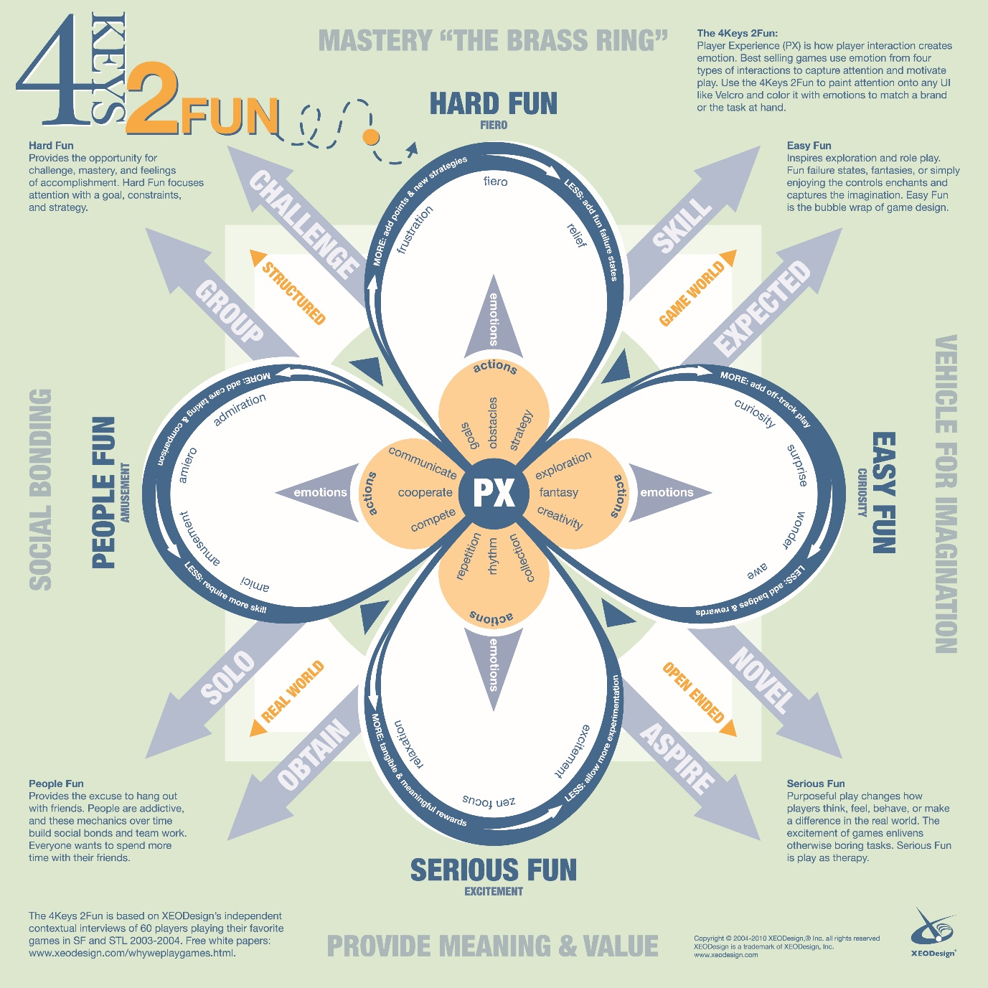
Bullet-Hell games require a sense of concentration and skill to dodge countless of enemy and boss patterns to progress forward. I think the best option would be “Hard Fun” and create balancing plates between these three emotions of fiero, frustration, and finally relief.
Core Strengths
- The core strength of bullet hell games is the endless value of replayability. From breaking your old score records on different modes, to non-stop frantic gameplay in different difficulty modes feel very rewarding once completed.
- Some with stories have a sense of progression to find out what happens once you reach the end of your journey.
Issues
- Monetisation off of free game websites or getting greenlighted on Steam to make revenue.
- Standing out from the rest of vast sea of bullet-hell games, something unique needs to be done to get noticed in that genre.
Genre and Demographic
- 2D, Shoot ‘em up vertical, side-scroller (Shmup for short or Bullet-Hell)
- 30+ year old males. Desirably gamers that grew up playing these types of games in arcades and on the SNES.
- Theme being war in the vast beauty of the empty and vacuum of space (may change.)
Artstyle Mood board
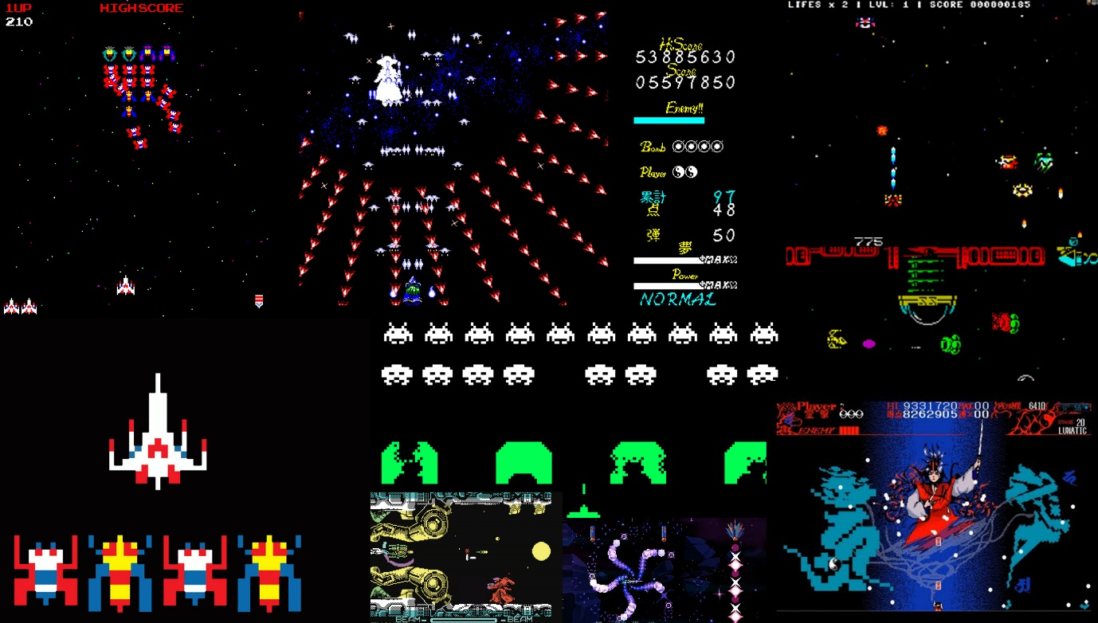
- 2D, pixel Artstyle not too complex in design and gives a rather nice and retro, arcade feel to games back in the 70s and 80s (may change.)
- Cartoonish style of spaceships and enemy craft.
- Use of primary colours, which colours mix together (reference to colour theory.)
- Simplistic UI to showcase player both normal and high score, boss health, life and bombs left etc.

Gameplay
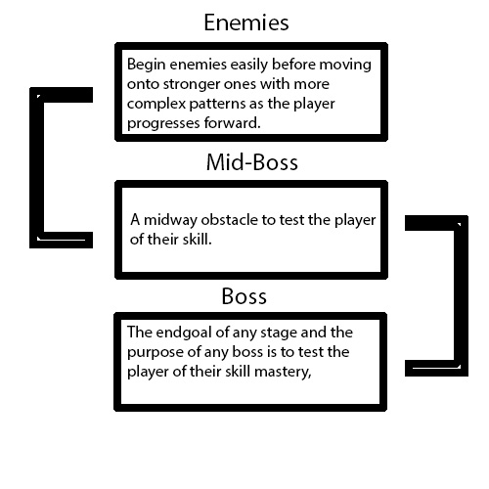
Adding a bit more detail to the boss section, the boss battles will have three different form. Each with more complex bullet-hell patterns than the previous to trigger the desired emotions within the player.
Unique Quirks – Small detail
- Implement Different attributes and playstyles
- Collect 6 “B” (bomb) or “L” (life) shards to gain a life or bomb
- Collect a stainable number of Special Energy (prototype name) to protect yourself when your hitbox is hit by an enemies bullet
Unique Quirks - In-depth
- Attributes and Playstyles
This area is known as the “Shot Select” which the player can choose different play styles such as Straight Shot, a powerful and a focused pattern which is ideal for precision and power. Versatile Wide-Firing, Ideal pattern if you want to hit most enemies most of the time. Variable Shot, pattern that follows the player and freezes when firing.
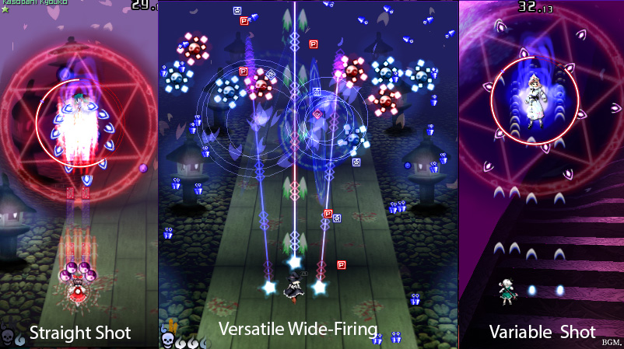
Attributes are the stats of each character such as their SPD (speed) and POW (power.)
- Bomb and Power collection
Like in the majority of shmup games which a mid-boss or special enemy drops a bomb or an extra life after defeat. I think it would be best for the player to collect bomb and heart pieces to fill up the 4 shard gauge before adding on an extra life or bomb to make things more challenging for the player.
- Bomb Protection
If the player is hit, turn all enemy bullets on screen to player score. The Player will not lose a life but will gain a lower score from using his special gauge. The special gauge will also have to be refilled again. It’s a one way life save mechanic in tough situations.

References
Anon, (2017). [online] Available at: http://www.sg4adults.eu/files/art-game-design.pdf [Accessed 3 Oct. 2017].
Barrish, C. (2017). A Detailed History of Shoot &#8216;Em Up Arcade Games. [online] Liberty Games. Available at: https://www.libertygames.co.uk/blog/a-detailed-history-of-shoot-em-up-arcade-games/ [Accessed 3 Oct. 2017].
Mari Calitri (2014). Touhou 8: Imperishable Night - no-death Normal walkthrough + captions. [online] YouTube. Available at: https://www.youtube.com/watch?v=QCvIr-xk1PU [Accessed 3 Oct. 2017].
NintenU (2017). Undertale - All Bosses. [online] YouTube. Available at: https://www.youtube.com/watch?v=Jfzvaw69h3g [Accessed 3 Oct. 2017].
Giant Bomb (2016). Devil Daggers: Quick Look. [online] YouTube. Available at: https://www.youtube.com/watch?v=ykRNauGI5kw [Accessed 3 Oct. 2017].
Craigsgames.com. (n.d.). [online] Available at: http://craigsgames.com/wp-content/uploads/2009/05/galaga.png [Accessed 3 Oct. 2017].
3.bp.blogspot.com. (n.d.). [online] Available at: http://3.bp.blogspot.com/-KJQ_vlALcJc/TcfB7Wuw-iI/AAAAAAAAAAg/Vnfa-rFrO2Y/s320/Touhou.jpg [Accessed 4 Oct. 2017].
I.pinimg.com. (2017). Cite a Website - Cite This For Me. [online] Available at: https://i.pinimg.com/originals/8e/43/4b/8e434bd1030aac8212740e40a2cfc886.jpg [Accessed 3 Oct. 2017].https://i.ytimg.com/vi/GgGhm7u6sr4/hqdefault.jpg
2.bp.blogspot.com. (2017). Cite a Website - Cite This For Me. [online] Available at: http://2.bp.blogspot.com/-UDDgwnDTkdg/Tt01Icp5ZqI/AAAAAAAACHg/orrAgzDeu-M/s1600/4+-+Zynaps.png [Accessed 3 Oct. 2017].http://cdn.mos.cms.futurecdn.net/bf7deeffa701dc3ba2de3bedb19c7471-650-80.jpg
Img-ak.pog.com. (2017). [online] Available at: http://img-ak.pog.com/cloud/y8-thumbs/64492/big.gif?1462126277 [Accessed 3 Oct. 2017].
Retrogamer.net. (2017). [online] Available at: https://www.retrogamer.net/wp-content/uploads/2014/12/R-Type-Spectrum-616x449.png [Accessed 3 Oct. 2017].

